**DB Lab 12**

**Name:** Hafsa Salman

**Roll no.** 22K-5161

**//Library Database**

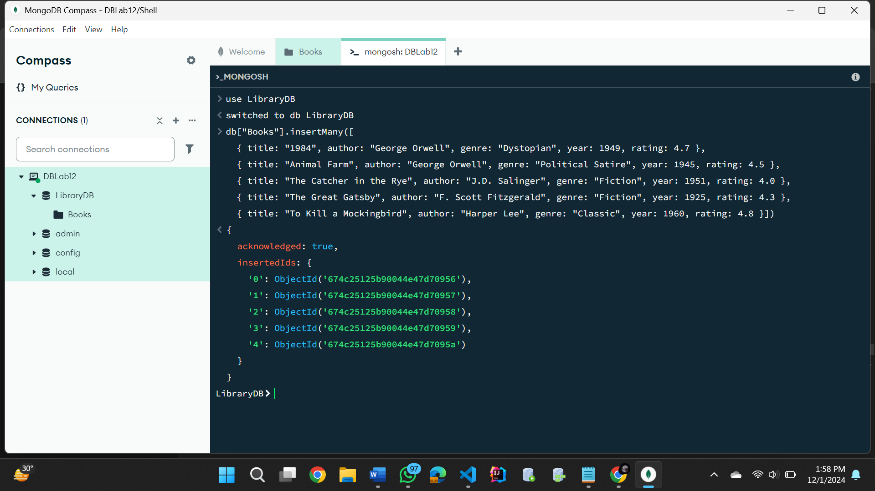

//Solutions from page 02

**Task no. 01**

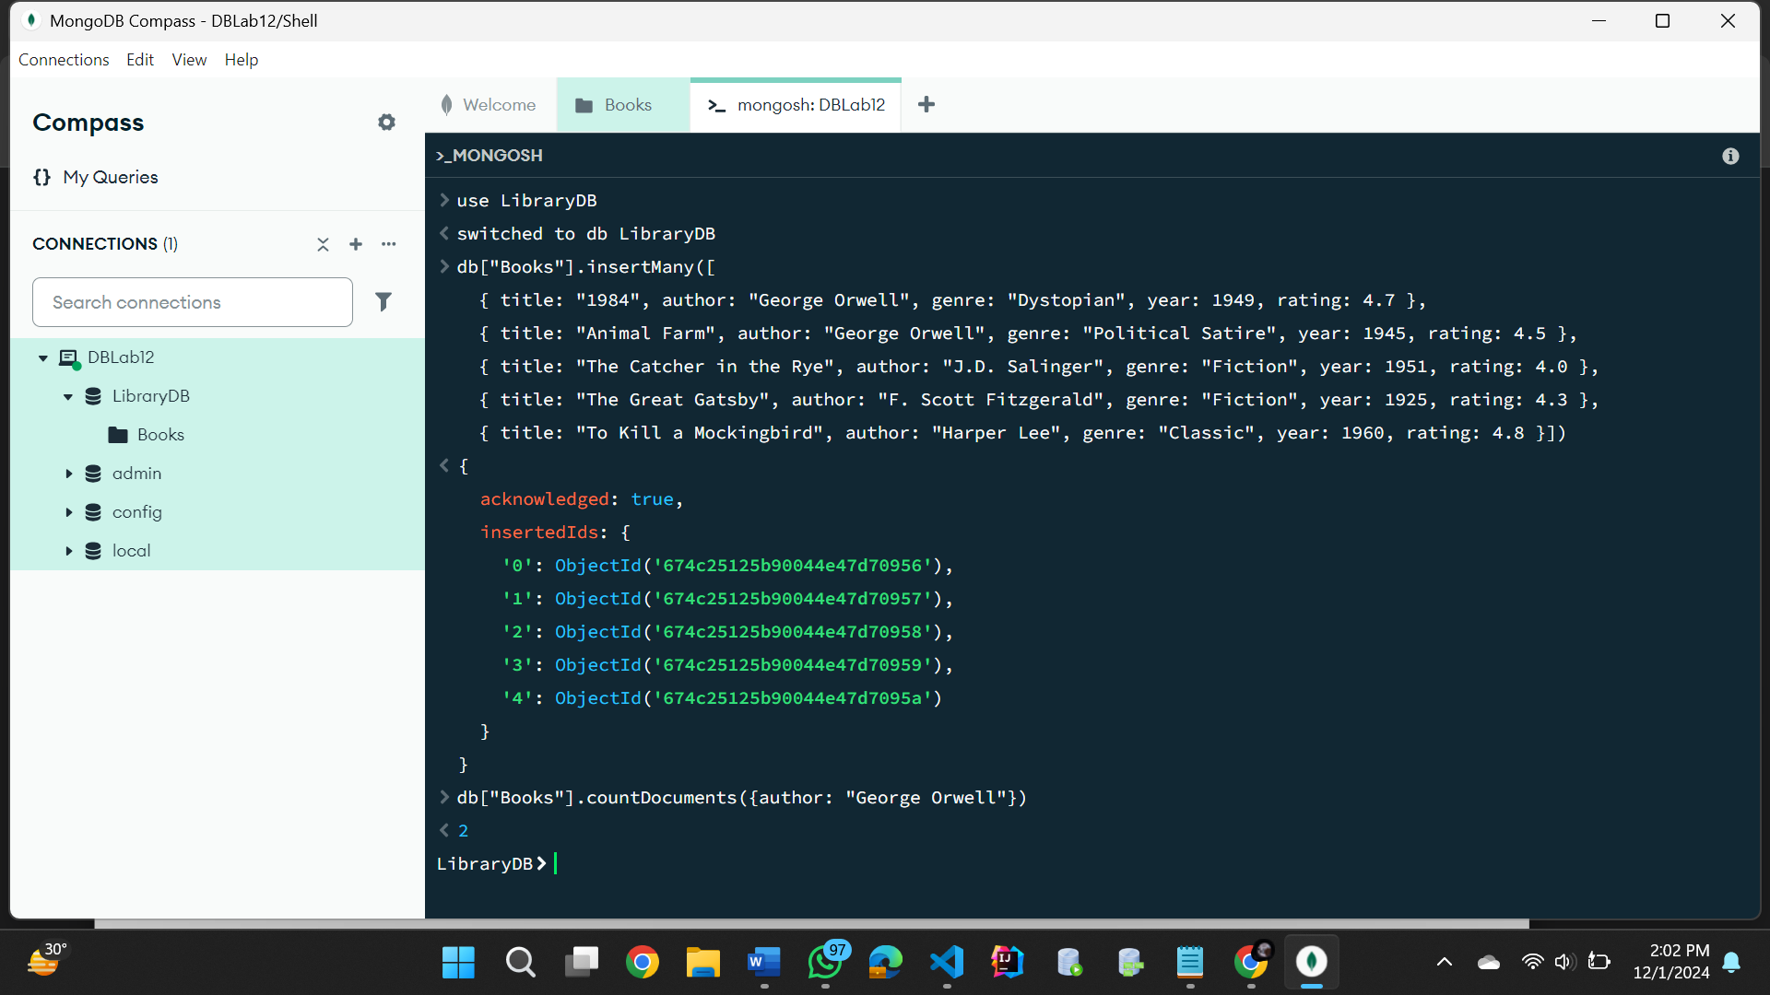

**Task no. 02**

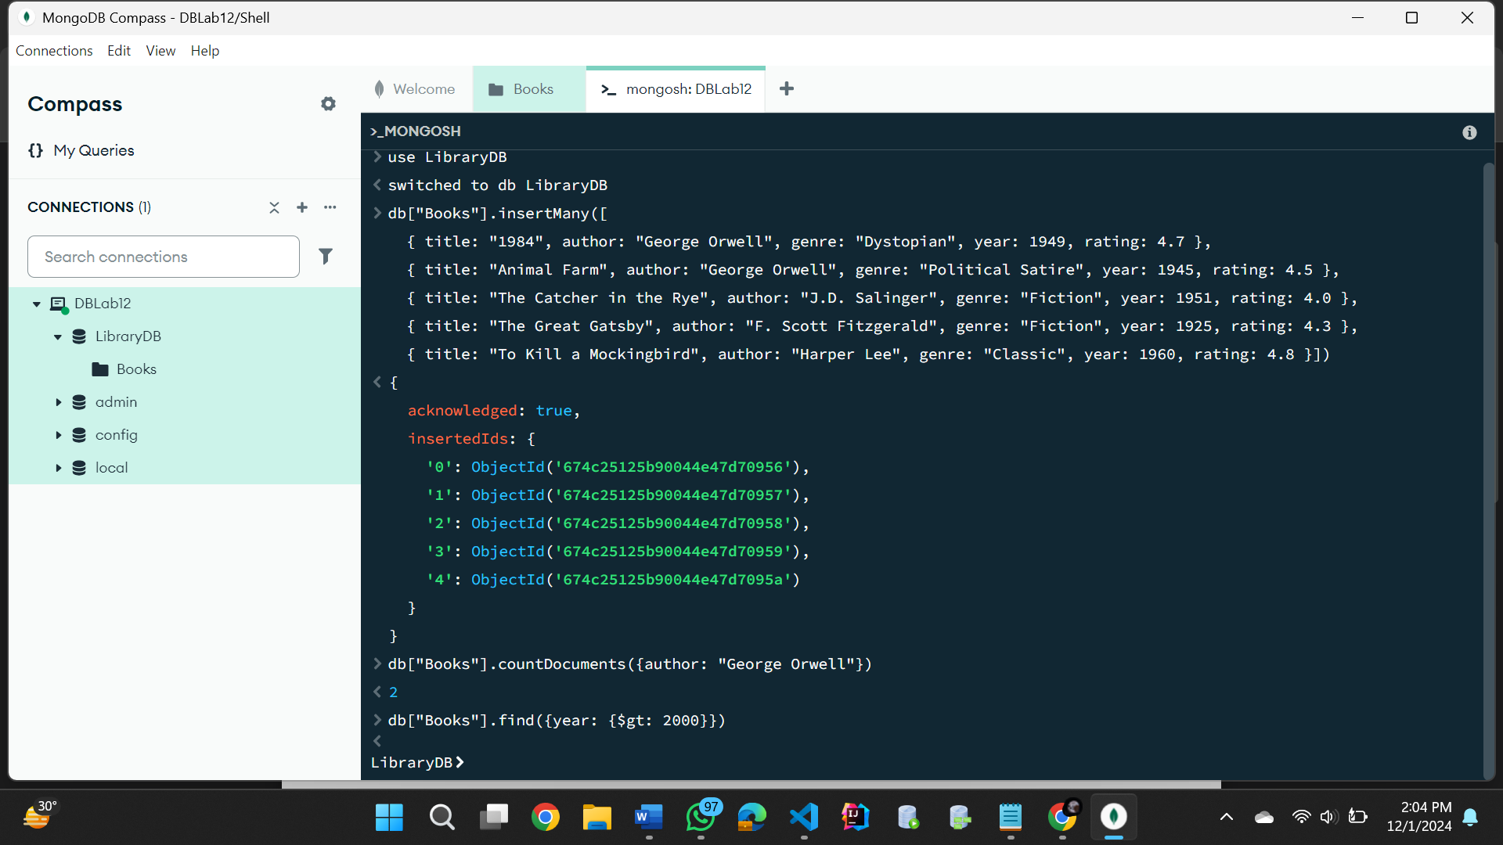

**Task no. 03**

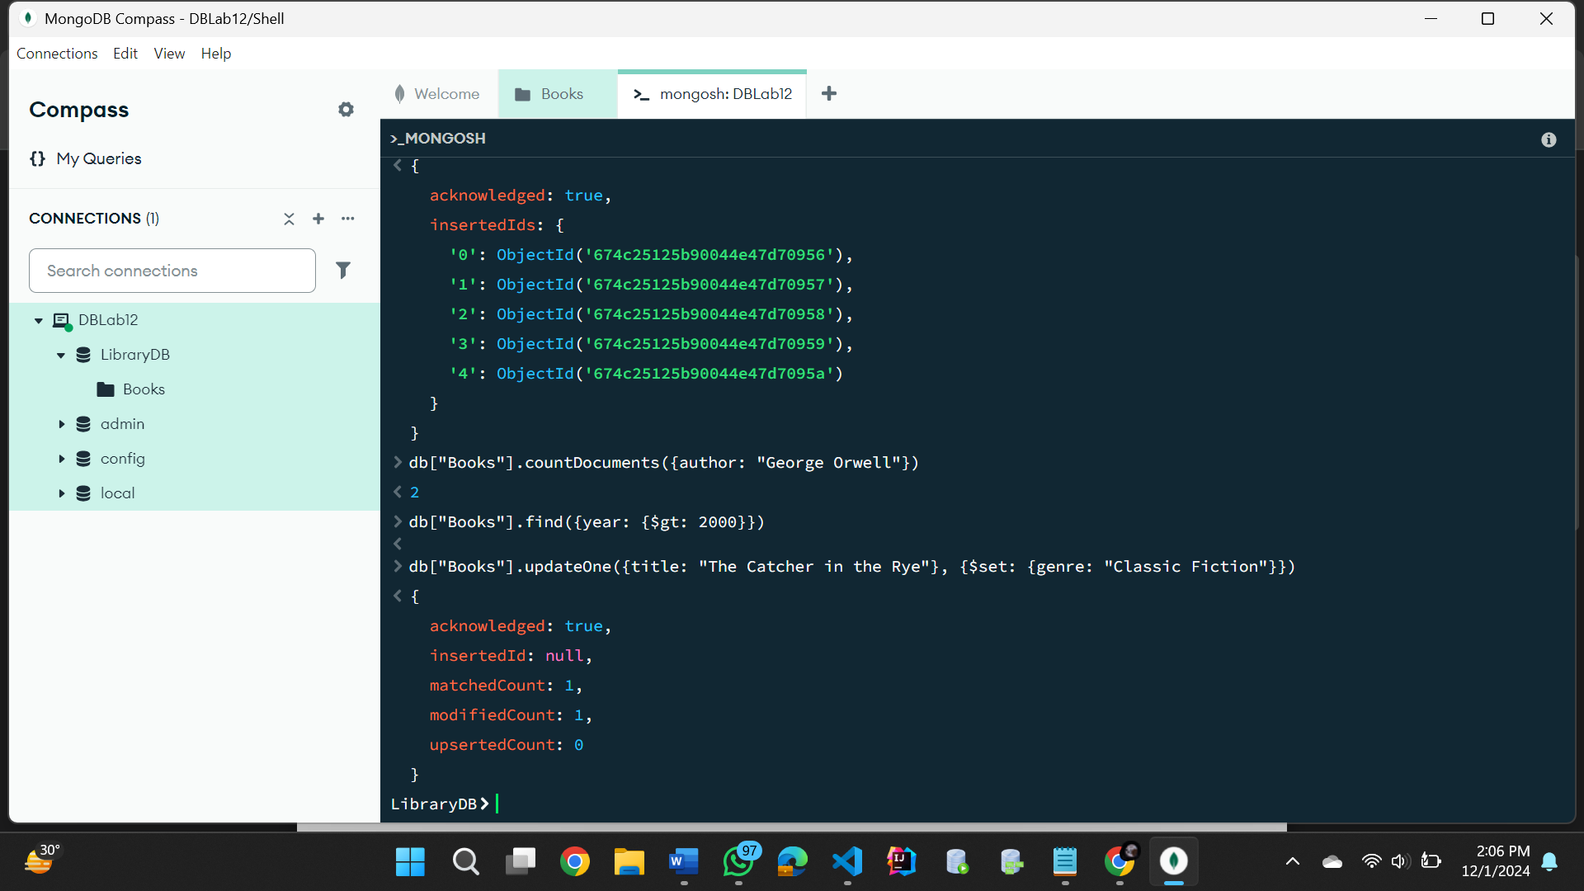

**Task no. 04**

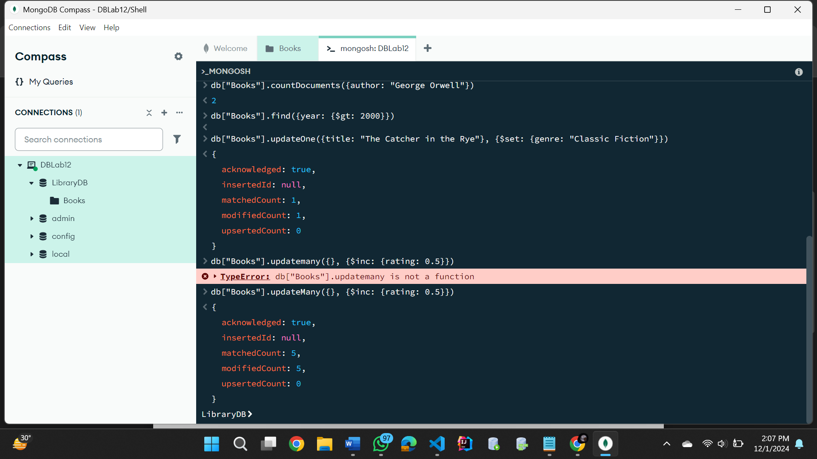

**Task no. 05**

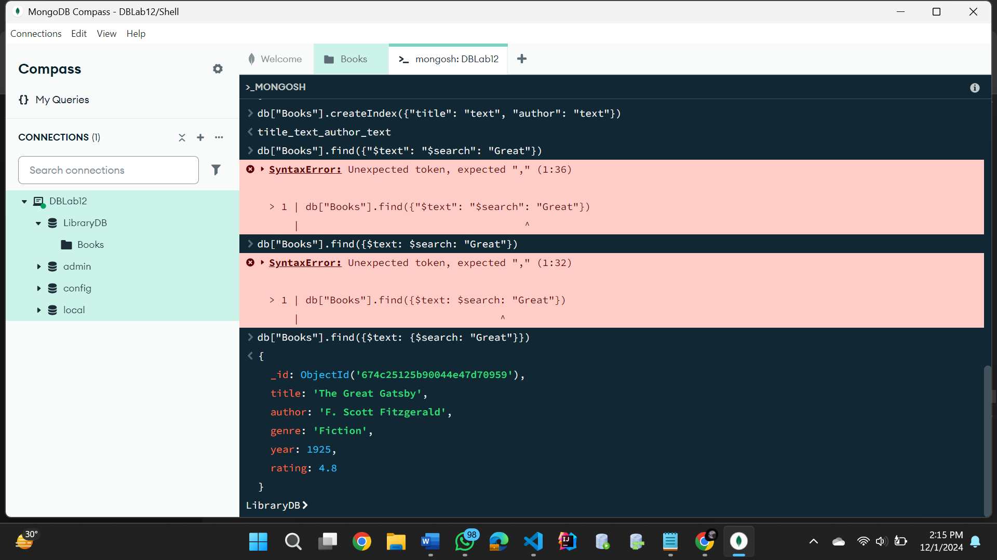

**Task no. 06**

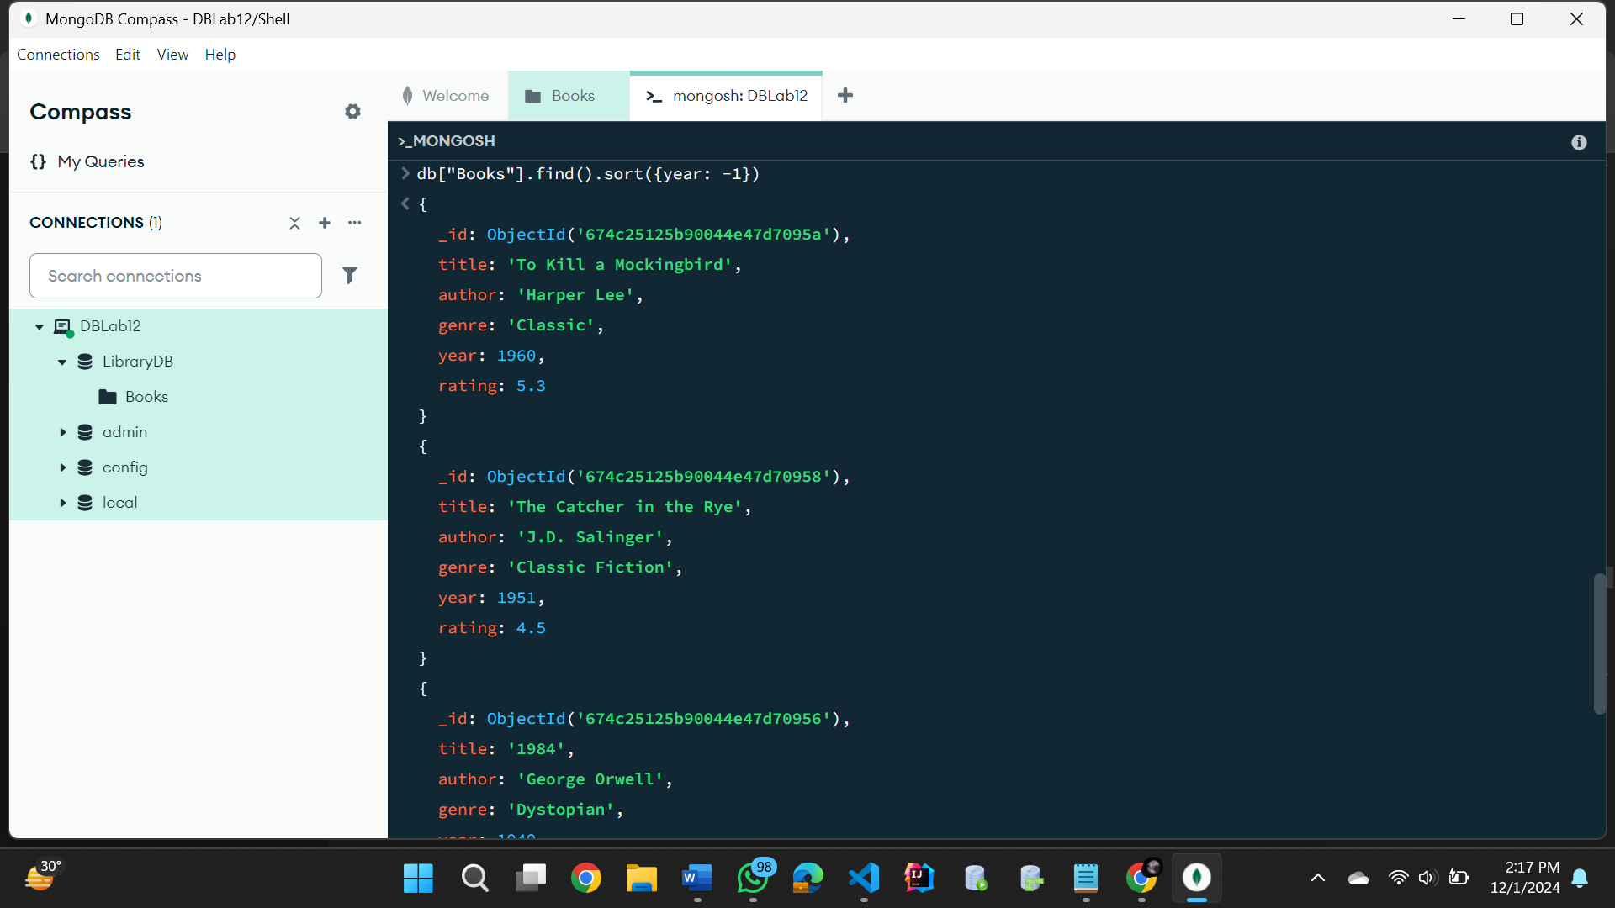

**Task no. 07**

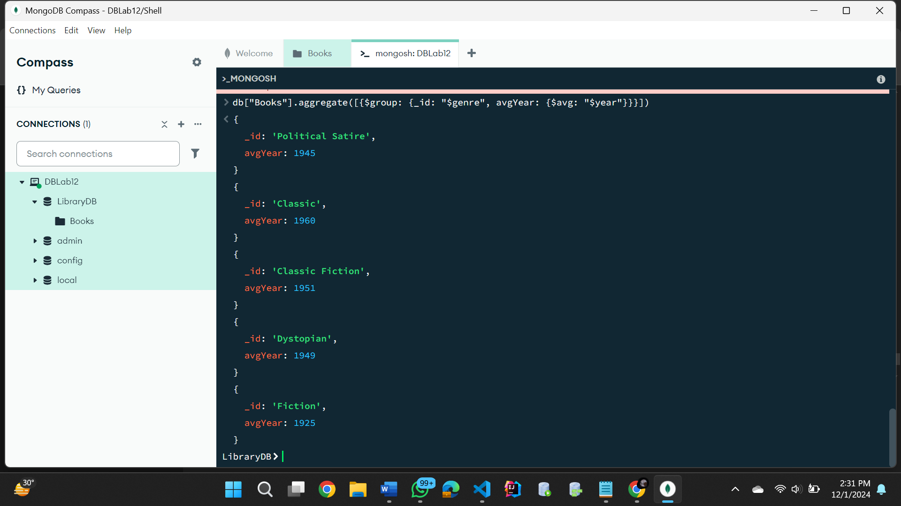

**Task no. 08**

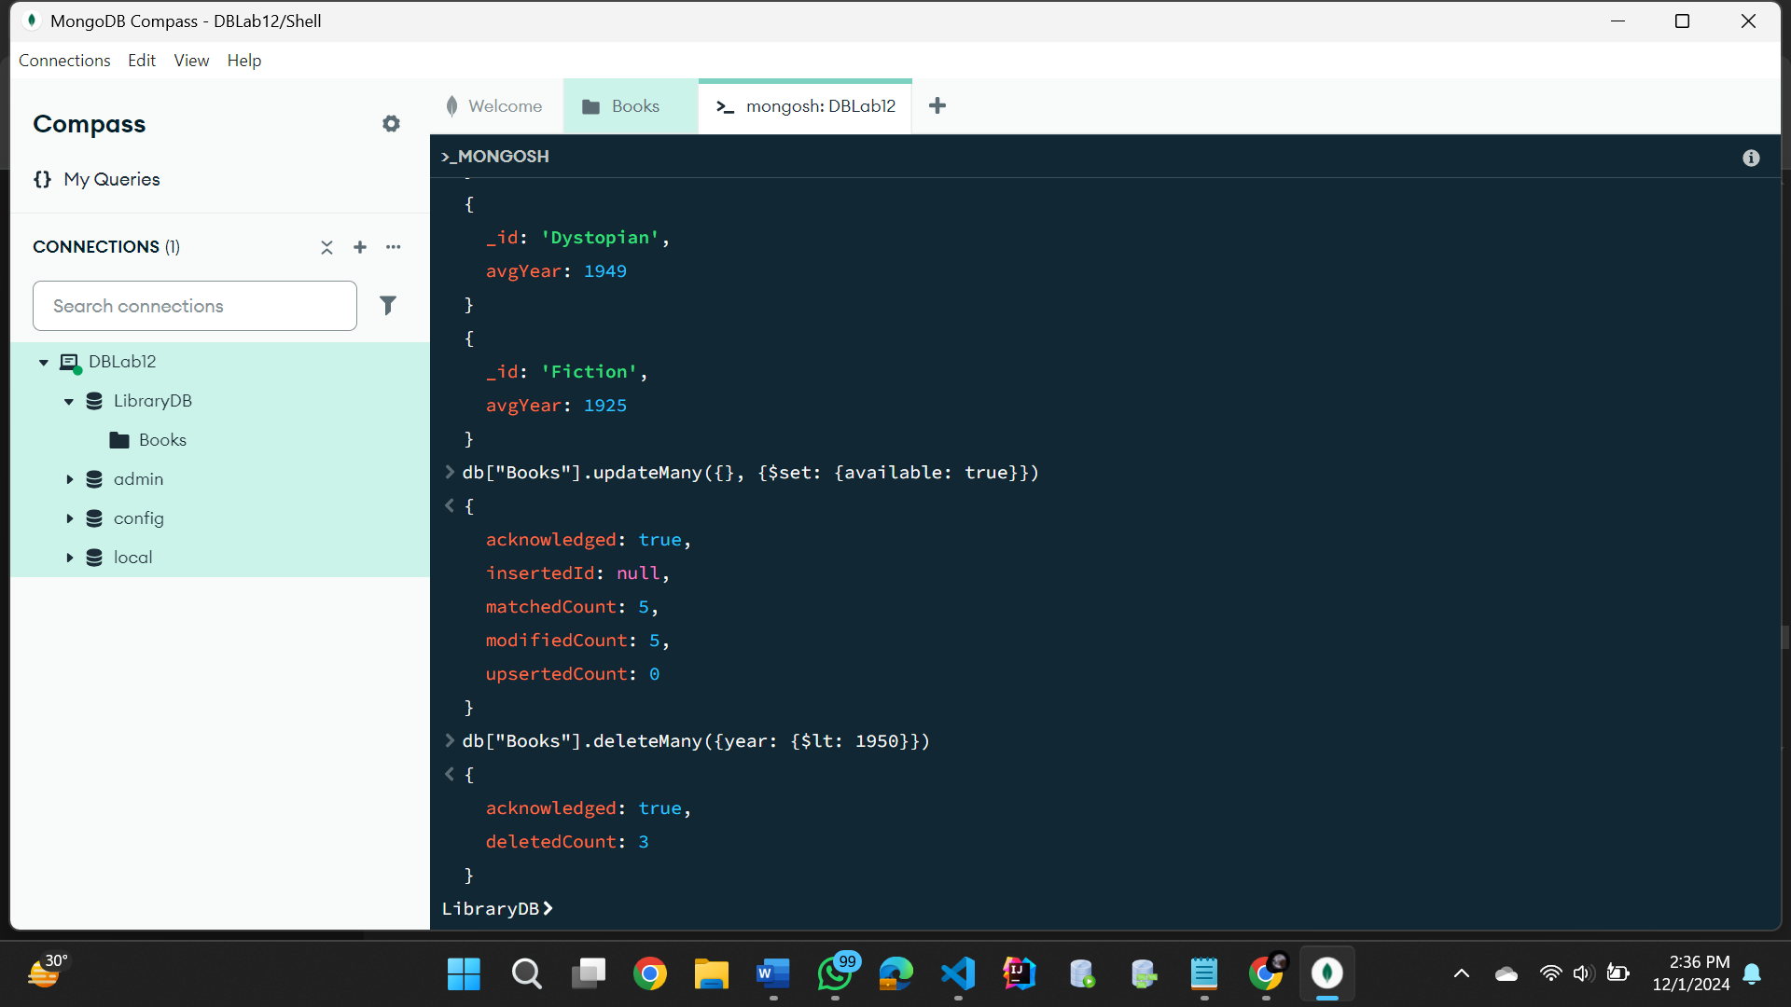

**Task no. 09**

**Task no. 10**

